TESTING OF XCROSS

REPORT

Website Tested
xcros.in
Testing Summary
The website was tested across multiple screen sizes and device resolutions to verify responsive behavior, content visibility, and layout alignment.

Responsive Testing Results
Device / Resolution | Observation | Status
Mobile S – 320px | Side content is not visible | Issue Found
Mobile M – 375px | Everything working properly | Passed
Mobile L – 425px | Everything working properly | Passed
Tablet – 768px | Upper heading is not visible | Issue Found
Laptop – 1024px | Layout working correctly | Passed
Laptop L – 1440px | Everything working properly | Passed
4K – 2560px | Content appears too small; zoom level around 50% | Issue Found
iPhone SE | “NEXUS” heading is not fully visible | Issue Found
iPhone XR | Everything working properly | Passed
iPhone 12 Pro | Everything working properly | Passed
iPhone 14 Pro Max | Everything working properly | Passed
Pixel 7 | All content working correctly | Passed
Samsung Galaxy S8+ | Upper content is not visible | Issue Found
Samsung Galaxy S20 Ultra | Everything working properly | Passed
iPad Mini | Upper content is not visible | Issue Found
iPad Air | Layout working correctly | Passed
iPad Pro | Layout working correctly | Passed
Surface Pro 7 | Everything working properly | Passed
Surface Duo | Upper content partially cut/not fully visible | Issue Found
Galaxy Z Fold 5 | Side content is not visible | Issue Found
Asus Zenbook Fold | Everything working properly | Passed
Samsung Galaxy A51/71 | Everything working properly | Passed
Nest Hub | Everything working properly | Passed
Nest Hub Max | Everything working properly | Passed

Issues Identified
- Side content visibility issue on smaller mobile screens.
- Upper heading/content visibility problem on certain tablet and Samsung devices.
- Heading alignment issue on iPhone SE.
- Content scaling issue on 4K resolution displays.
- Partial content clipping observed on foldable devices.

Testing Objective
The website navigation links, buttons, QR functionality, and interactive sections were tested to verify whether all pages and features are functioning correctly.

Navigation and Feature Testing Results

Module/Page | Tested Functionality | Observation | Status
Home Page | Privacy Policy Link | Link is not working / page not opening | Failed
Home Page | Terms & Conditions Link | Link is not working / page not opening | Failed
Home Page | World Icon Navigation | Navigation not functioning properly | Failed
Beta Version Page | QR Code Scan | Displays message “Code are disactivated” after scanning | Failed
Chat by Admin Page | Overall Page Functionality | Page not functioning properly | Failed
Chat by Admin Page | Set Up Notifications | Feature not working | Failed
Chat by Admin Page | Submit a Ticket | Button/functionality not working | Failed
Chat by Admin Page | Knowledge Base | Page/feature not opening | Failed
Chat by Admin Page | Video Tutorials | Navigation not working | Failed
Chat by Admin Page | Reviews Section | Feature not functioning | Failed
Chat by Admin Page | Forum | Navigation/functionality not working | Failed
Chat by Admin Page | ChatGPT Feature | Not accessible / not working | Failed
Chat by Admin Page | AI Feature | Feature not functioning properly | Failed
Chat by Admin Page | Whiteboard | Tool/page not working | Failed

Issues Identified
- Multiple footer and navigation links are inaccessible.
- QR code functionality on the Beta Version page is inactive.
- Several features inside the Chat by Admin page are non-functional.
- Interactive modules and support-related sections are not responding properly.
- AI and collaboration tools such as ChatGPT and Whiteboard are currently inaccessible.

Additional Observation – Beta Version Page Testing

Module/Page | Tested Functionality | Observation | Status
Beta Version Page – Chennai Location | Launch Sponsors Section | Some sponsor images are not visible/loading properly | Failed

Issue Description
During testing of the Beta Version Page under the Chennai city location, it was observed that certain images in the Launch Sponsors section were not displayed properly. Some images appeared missing or failed to load, affecting the visual layout and user experience.

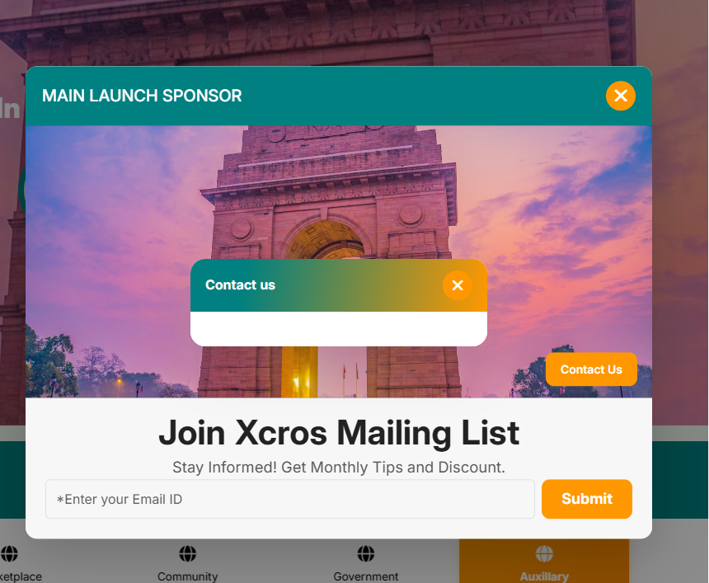

In Chennai contact us page isn’t working.

Beta Version Page Testing
Module/Page | Tested Functionality | Observation | Status
Beta Version Page | View All Pincodes | Some images are not displayed properly | Failed
Beta Version Page | Contact Us Page | Page not opening/displaying | Failed

Feature Listing – Business Page
Module/Page | Tested Functionality | Observation | Status
Business Page | Featured Listing Images | Some images are not visible | Failed
Business Page | Sort Feature – “Most Viewed” | Sorting functionality not working | Failed

Feature Listing – Professional Page

Module/Page | Tested Functionality | Observation | Status
Professional Page | The Grand Spice Kitchen Image | Image not displayed | Failed
Professional Page | Book an Appointment | Button/functionality not working | Failed

Feature Listing – Handyman Page

Module/Page | Tested Functionality | Observation | Status
Handyman Page | Book an Appointment | Functionality not working | Failed
Handyman Page | The Grand Spice Kitchen Image | Image not displayed | Failed

Explore Popular Categories Section

Category | Observation | Status
Women Fashion | The Grand Spice Kitchen image not shown | Failed
Sports and Outdoors | The Grand Spice Kitchen image not shown | Failed
Real Estate | The Grand Spice Kitchen image not shown | Failed
Home and Garden | The Grand Spice Kitchen image not shown | Failed

Promoted Category Section
Module/Page | Observation | Status
Promoted Category | The Grand Spice Kitchen image not displayed | Failed

Issues Identified
- Multiple images across different sections are missing or not loading properly.
- Contact Us page is inaccessible.
- Sorting/filter functionalities are not functioning correctly.
- “Book an Appointment” feature is inactive on several pages.
- Repeated image loading issue observed for “The Grand Spice Kitchen” listing across multiple categories and sections.

Issue Description
During testing of the Explore Popular Categories section, it was observed that the restaurant jingle/audio feature inside the promoted listing pages is not functioning properly. The audio does not play when accessed, indicating a possible issue with media loading or audio integration.

Recommendation
- Verify audio file source paths and media availability.
- Check browser autoplay and audio permissions.
- Ensure proper frontend integration for jingle playback functionality.
- Validate audio compatibility across devices and browsers.

Beta Version Page – Contact Us

Module/Page | Tested Functionality | Observation | Status
Beta Version Page | Contact Us Section | Content/page not displaying properly | Failed

Terms and Conditions Page Testing

Module/Page | Observation | Status
Terms and Conditions Page | HTML/code content is displayed directly instead of formatted text and links | Failed

Issue Description
The Terms and Conditions page displays raw HTML/code text instead of properly rendered webpage content. The following content is visible on the page:

p /ppstrongCorporate:/strong a href="www.gudvil.nexus" target="_blank"www.gudvil.nexus/aspan style="color: windowtext;" /spanspan style="color: rgb(51, 51, 255);" /span/ppspan style="color: rgb(51, 51, 255);" /span/ppstrongProject:/strong a href="www.xcros.in" target="_blank"www.xcros.in/a/p
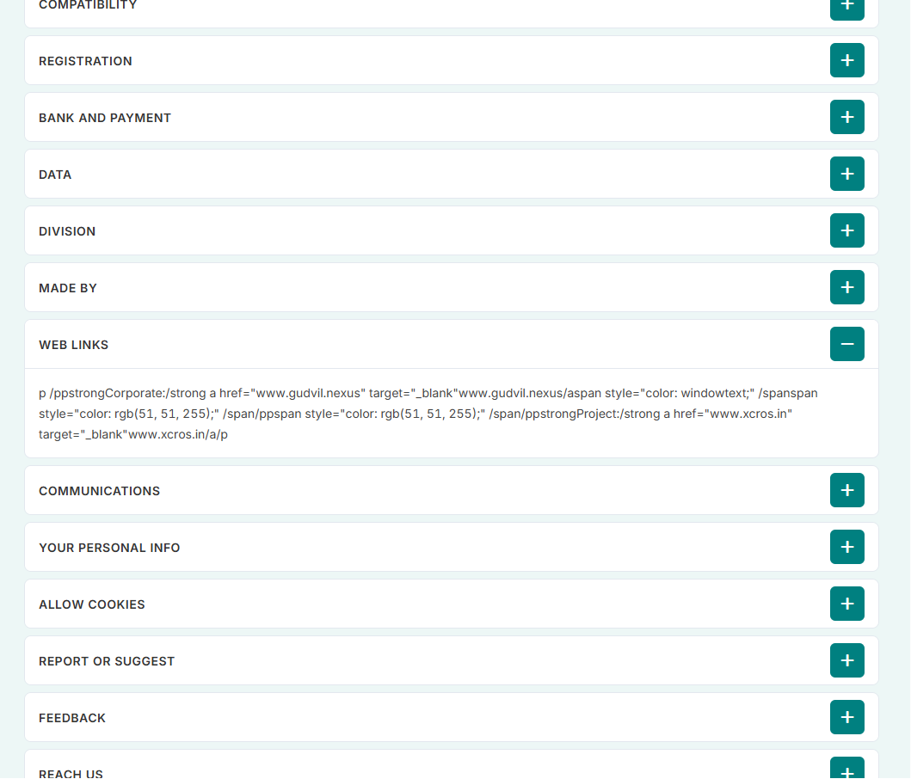
Possible Cause
- HTML tags may not be rendered correctly.
- Backend/frontend content formatting issue.
- Improper HTML parsing or escaped content display.

Cookies – Manage Consent Preferences Testing

Module/Page | Observation | Status
Cookies – Manage Consent Preferences | Radio button options and alignment/content display are improper | Failed

Displayed Content Observed
Strictly Necessary – Always Active

Functional – (Radio active button)

Performance and Analytics – (Radio active button)

Targeting – (Radio active button)

Issue Description
The cookie consent preference section appears improperly formatted. The radio button options and text alignment are not displayed professionally, affecting usability and user experience.

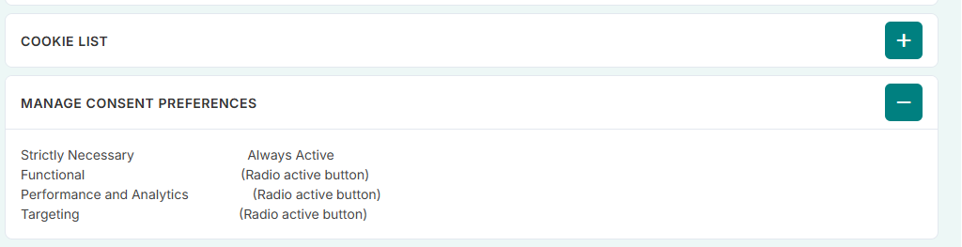

Menu Bar – Support Section Testing

Module/Page | Tested Functionality | Observation | Status
Menu Bar → Support → Help Center | View by Pincode | Feature/navigation not functioning properly | Failed
Menu Bar → Support → Help Center | Connect Option | Functionality not working properly | Failed

Vertical Services Navigation Testing

Module/Page | Tested Functionality | Observation | Status
Vertical Services Section | Navigation Functionality | Redirects incorrectly to “Choose Service” page instead of “Vertical Services” page | Failed

Gallery Section Testing
Module/Page | Tested Functionality | Observation | Status
Gallery Section | Add Button | Button not functioning | Failed
Gallery Section | Ad Images | Images not loading/displaying properly | Failed

Helpline and Emergency Number Section Testing

Module/Page | Tested Functionality | Observation | Status
Helpline & Emergency Number Section | Get Direction | Navigation/button not working | Failed

Issues Identified
- Support section features such as “View by Pincode” and “Connect” are not functioning properly.
- Incorrect page redirection observed in the Vertical Services section.
- Gallery section contains inactive buttons and missing advertisement images.
- “Get Direction” option in the Helpline & Emergency section is not operational.

Help Center – View Profile Testing

Module/Page | Tested Functionality | Observation | Status
Menu Bar → Support → Help Center → View Profile | Reviews Section | Images are not displayed properly | Failed
Menu Bar → Support → Help Center → View Profile | Service Agents Section | Agent images are not visible | Failed
Menu Bar → Support → Help Center → View Profile | More Button | Button/functionality not working | Failed

Advertisement Carousel Testing

Module/Page | Tested Functionality | Observation | Status
Advertisement Carousel | Carousel/Slider Functionality | Carousel is not sliding/functioning properly | Failed

Issues Identified
- Images in the Reviews and Service Agents sections are missing or not loading correctly.
- “More” button inside the View Profile section is inactive.
- Advertisement carousel functionality is not operational.

Service Market – Search Setting Testing

Module/Page | Tested Functionality | Observation | Status
Menu Bar → Support → Help Center → Service Market | Search Setting Dropdown | Dropdown menu is not functioning/responding properly | Failed

Issue Description
During testing of the Service Market section inside the Help Center, it was observed that the Search Setting dropdown is not working properly. Clicking the dropdown does not display options or perform the expected action.

Service Market → Store Testing

Module/Page | Tested Functionality | Observation | Status
Menu Bar → Support → Help Center → Service Market → Store | Price Range Filter Bar | Price range slider/bar is not functioning properly | Failed
Menu Bar → Support → Help Center → Service Market → Store | Store/Product Images | Images are not loading/displaying properly | Failed

Issue Description
During testing of the Store section inside the Service Market page, the following issues were identified:
- The Price Range Filter Bar is non-functional and does not respond properly when adjusted.
- Several store/product images are missing or not displayed correctly.

Possible Causes
- JavaScript or filter event handling issue in the price range component.
- Broken image paths or missing image assets.
- API/backend response issue affecting image loading.
- UI rendering or frontend integration problem.

Vertical Markets → Expo Testing

Module/Page | Tested Functionality | Observation | Status
Menu Bar → Vertical Markets → Expo | Expo Calendar Button | Button is not functioning/responding properly | Failed

Issue Description
During testing of the Expo section under Vertical Markets, it was observed that the Expo Calendar button is not working. Clicking the button does not perform the expected navigation or action.

Possible Causes
- Broken button link or routing issue.
- JavaScript click event not functioning.
- Backend/API integration problem.
- Incorrect page redirection configuration.

Recommendation
- Verify button navigation path and routing.
- Check frontend click event handling.
- Validate backend response and calendar page integration.
- Inspect browser console for related errors.

About → Careers Section Testing
Module/Page | Tested Functionality | Observation | Status
Menu → About → Careers | Explore Opportunities | Button/link is not navigating properly | Failed

Gudvil-Nexus Section Testing

Module/Page | Tested Functionality | Observation | Status
Gudvil-Nexus | Services Navigation | Services option is not navigating properly | Failed
Gudvil-Nexus | Get Social | Displays blank/empty page | Failed

Issue Description
During navigation testing, the following issues were identified:
- The Explore Opportunities option inside the Careers section is non-functional and does not redirect properly.
- The Services option under Gudvil-Nexus is not working as expected.
- The Get Social page opens as a blank/empty page without content.

Possible Causes
- Broken or missing navigation links.
- Incorrect routing configuration.
- Backend/API response issues.
- Missing page content or frontend rendering problems.

Recommendation
- Verify all navigation routes and link mappings.
- Check frontend integration for Careers and Gudvil-Nexus sections.
- Validate page rendering and content loading functionality.
- Inspect browser console for routing or API-related errors.

Overall Conclusion
The website testing process for XCROS.in identified multiple issues related to responsiveness, navigation, UI rendering, image loading, and feature functionality across different modules and devices. Testing was conducted on various mobile, tablet, laptop, desktop, and foldable device resolutions to evaluate the website’s performance and user experience.
Several sections of the website were functioning correctly; however, many modules contained broken links, inactive buttons, missing images, improper page redirections, non-functional dropdowns, blank pages, and rendering issues. Problems were also observed in responsive layouts, audio playback features, filter functionalities, QR code integration, carousel behavior, appointment booking options, and support-related pages.
The testing results indicate that the website requires further frontend optimization, backend integration validation, responsive UI improvements, and functionality debugging to ensure smooth navigation and consistent performance across all devices and screen sizes.
Overall, the testing helped identify critical usability and functionality issues, and a detailed report was prepared to support the development team in fixing and improving the website before production-level deployment.

